Lab Experiments
9.To implement TD (0), SARSA, and Q-Learning algorithms for a warehouse robot to optimize navigation and obstacle avoidance.
Code:
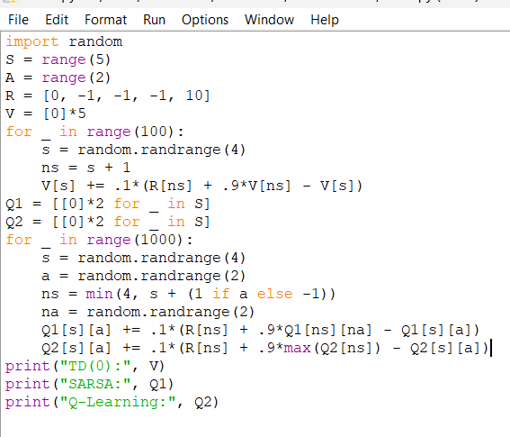
Output:
